DESIGN AND ANALYSIS OF ALGORITHMS
(II- B. Tech.  IV Semester)
Assignment-1 Questions
Academic Year-2023-2024
SET-1
- Define an algorithm. Write pseudo code for expressing the algorithm?
- Describe control abstraction of divide and conquer and write its time complexity?
- Write UNION and FIND Algorithms along with their time complexities?

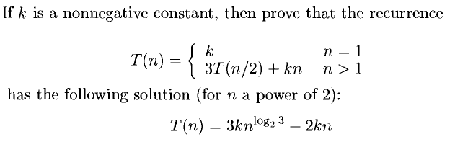
- Find the shortest path for the given graph by using single source shortest path.(source is A and destination is E.)
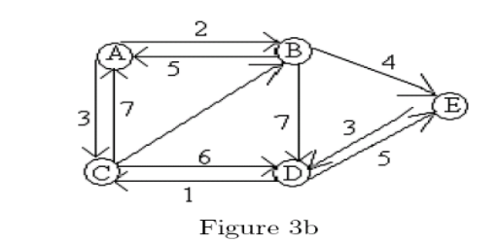

SET-2
- Define Time complexity. Explain different method of time complexity with an example.
- Analyze the average case time complexity of Quick sort.?
- Given instance is, n=5, (p1, p2, ....., p5)=(w1,w2, .....,w5)=(4,4,5,8,9) and m=15.Solve knapsack problem by using Greedy method
- Prove that Prims algorithm method generates the minimum cost spanning tree?
- Summarize the concept of biconnected components with an example?

SET-3
- State the difference between BFS and DFS with an example?
- Derive the time complexity of Strassen Matrix multiplication is O(n^{2.81})?
- Solve the following problem using the Job sequencing with dead line algorithm and also find the optimal solution for the instance n=7, (P1, P2, ......., P7)=(3,5,20,18,1,6,30) and (D1,D2, .......,D7)=(1,3,4,3,2,1,2).
- Illustrate the concept of Knapsack problem with an example?
- Write a pseudo code of Merge Sort and derive its Time Complexity?

SET-4
- Trace the Merge sort algorithm for the given array. Also show the tree of calls for Merge sort. 25, 57, 48, 37, 12, 92, 25, 86, 33 ?
- List out different types of asymptotic notations with example?
- State and explain the Kruskal algorithm, by applying the algorithm construct a minimal cost spanning tree for graph given below.
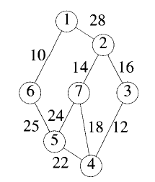
- Estimate the time complexity Job sequence with deadlines by writing the algorithm.
- What is performance analysis? Explain about space complexity with an example?

